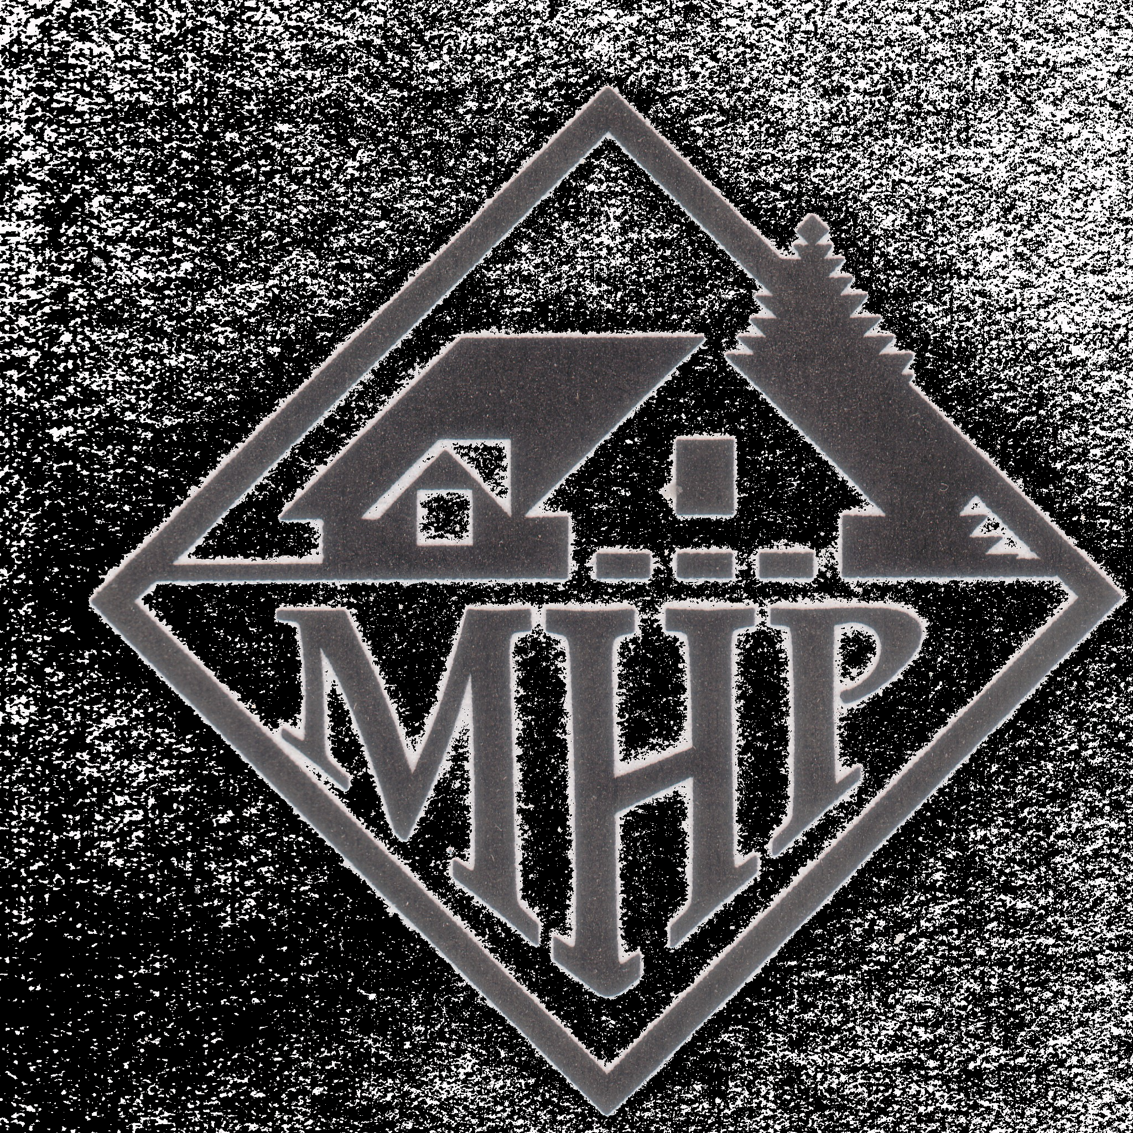
Shady Oaks Mobile Home Park, LLC

PO Box 1908, Crested Butte, CO 81224

----------------------------------------------------------------------------------------

February 1, 2021

Dear Ms. Semelbauer,

You have been approved for residency in Shady Oaks MHP, Lot #17. The amount of your monthly rent will be $335.00.

A copy of your new lease and park rules is enclosed. The park will be responsible for water, sewer, and trash collection. You are responsible for your gas, electric, television, phone and internet. Contact info for the electric and gas companies can be found on page two of the Rules.

Regarding the enclosed lease, here’s what we need:

- Review the names on page 1 to make sure it accurately reflects the names of the people living in your home. Please make additions or deletions as necessary.
- Sign and date in the spaces provided on page 3 of the lease.
3. Sign and date the last page of the rules
- Please return to Deb. She will forward to me and I will sign and provide a copy to you.

For your mailbox, call the Muskegon Post Office at (231) 722-7292 and talk to them about obtaining a mailbox in one of the two kiosks out in front of the park. The cost for keys (if any) is your responsibility.

We look forward to providing you with a nice community to call home.

Sincerely,

Joe Matyk
Shady Oaks MHP, LLC

